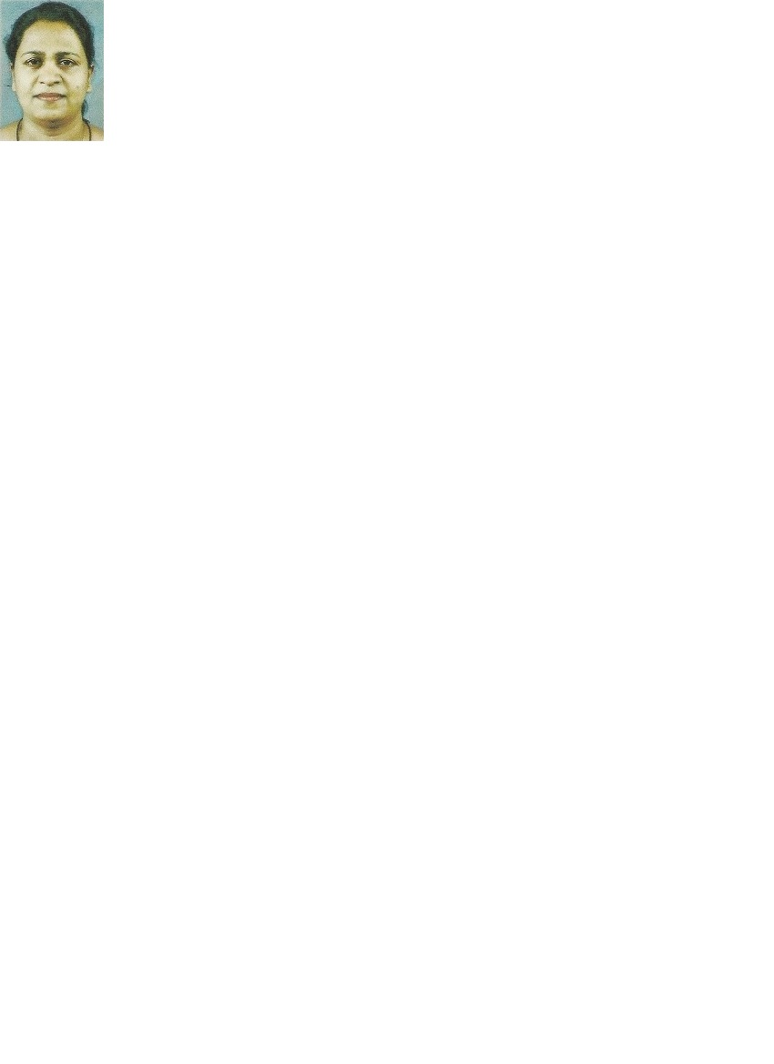**CURRICULUM VITAE**

**Gayani Ranatunge**

No No. 39/2B Wathuwala, Katugasthota.

077-0328194

[gayanirana@yahoo.com](mailto:gayanirana@yahoo.com)

1. **Date of Birth** : 19th July 1974
2. **Gender** : Female
3. **Nationality** : Sinhalese
4. **Religion** : Buddhist
5. **NIC No.** : 747012270V
6. **School Attended** : St Anthony’s Girls’ School, Kandy.
7. **Academic Qualifications**

G.C.E. (O/L) Examination Sinhala Medium ( 1990)

**Subject Grade**

Mathematics Distinction

Home Science Distinction

Sinhala Credit Pass

English Credit Pass

Buddhism Credit Pass

Science Credit Pass

Social Studies Credit Pass

Arts Simple Pass

G.C.E. (A/L) Examination Sinhala Medium (1994)

**Subject Grade**

Botany Simple Pass

Zoology Simple Pass

1. **Professional Qualifications**

* Completed ACS (Australian Computer Society) examination and passed all four subjects.
* Completed Computer Hardware Engineering Course at Arther C’ Clark institution, Moratuwa.
* Completed 3 months full time MS Office course at IBS Bambalapitiya.
* Completed Graphic Designing Course at IDM, Kandy.
* Presently following 3D modeling Course at Wijaya Graphics, Kandy.

1. **Working Experience**

* Worked at Kothmale Motor Traders, Kandy for 5 years and hold positions as

Vehicle bidding in charge & Vehicle Import Manager.

* Worked as a Computer Instructor at Seetha Devi Balika Vidyalaya, Kandy since October 1996 to June 1997.
* Worked as a Computer Lecturer at National Youth Service Centre Kandewatte Mawanella, since August 2003 to September 2004.
* Worked as a Computer Lecturer at Londentec International Nugawela Branch, since 2006 to October 2008.

1. **Extra Curricular Activities**

* Member of School Chess Committee.
* Hold a Membership of Kantha Samithi (Women Society) at Harispaththuwa Pradeshiya saba.
* Member of School chess team and gained championships.
* Member of Youth Service Center.
* Participated in Netball, Cricket and Chess teams and gained Championships.
* Passed Sunday School Examinations with honest.

I do hereby declare that the above given details are true and accurate to the best of knowledge. And I assure the best service if I were selected by you.

Thank You,

Yours truly

Gayani Ranatunge